Chi-square
I. Objective. To utilize the Chi-square test to determine whether experimentally obtained data constitutes a good fit to an expected ratio or value. To interpret a Chi-square value in terms of the probability of an event occurring. To correctly identify the null and alternative hypotheses when using a Chi-square test.
II. Principle. The Chi-square test is commonly used to demonstrate how closely an experimentally derived value agrees with an expected value. More specifically, chi-square is one among many different statistical tests designed to provide an estimate of the probability that an observed value did or did not occur by chance alone. This principle can best be described with an example.
Example 1: A scientist wants to sample a population of birds for the ratio of males to females. It is generally expected that these birds will exist in a ratio of 50:50. In other words, if you collected one hundred of these birds 50 would be male and 50 would be female. However, when the scientist actually collects 100 of the birds he collects 45 males and 55 females.
This issue raises the following important questions:
Are the observed values close enough to the expected values to be scientifically accepted?
Were the scientist’s observed values due to chance occurrence or is there actually a difference in the gender ratio of this bird?
Example 2: Everyone knows that when you flip a coin, you have a 50 percent chance of heads and a 50 percent chance of tails. This means that out of 100 flips you should get 50 heads and 50 tails. However, if you actually flip a coin 100 times, a 50:50 ratio is only one among many possible outcomes. What if you get a ratio of 48 heads to 52 tails? Is this really the same as 50:50? How can we be certain that what we observe agrees with what we expect taking into account the role that chance plays?
Fortunately, we have a χ² (chi-square) formula for determining what is chance and what is not chance:
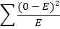
Where O is your observed value and E is an expected value.

If you take our previous coin example:
Hypothetical Chi-Square
Coin | Observed value | Expected value | (O-E) | (O-E)² | (O-E)²/E
Heads | 48 | 50 | -2 | 4 | .08
Tails | 52 | 50 | 2 | 4 | .08
Total | 100 | 100 |  |  | .16

You get a χ² value of 0.16. However, this value means nothing without a table of χ² values.
Degrees of Freedom (df) | Probability (p)
 | 0.95 | 0.90 | 0.80 | 0.70 | 0.50 | 0.30 | 0.20 | 0.10 | 0.05 | 0.01 | 0.001
1 | 0.004 | 0.02 | 0.06 | 0.15 | 0.46 | 1.07 | 1.64 | 2.71 | 3.84 | 6.64 | 10.83
2 | 0.10 | 0.21 | 0.45 | 0.71 | 1.39 | 2.41 | 3.22 | 4.60 | 5.99 | 9.21 | 13.82
3 | 0.35 | 0.58 | 1.01 | 1.42 | 2.37 | 3.66 | 4.64 | 6.25 | 7.82 | 11.34 | 16.27
4 | 0.71 | 1.06 | 1.65 | 2.20 | 3.36 | 4.88 | 5.99 | 7.78 | 9.49 | 13.28 | 18.47
5 | 1.14 | 1.61 | 2.34 | 3.00 | 4.35 | 6.06 | 7.29 | 9.24 | 11.07 | 15.09 | 20.52
6 | 1.63 | 2.20 | 3.07 | 3.83 | 5.35 | 7.23 | 8.56 | 10.64 | 12.59 | 16.81 | 22.46
7 | 2.17 | 2.83 | 3.82 | 4.67 | 6.35 | 8.38 | 9.80 | 12.02 | 14.07 | 18.48 | 24.32
8 | 2.73 | 3.49 | 4.59 | 5.53 | 7.34 | 9.52 | 11.03 | 13.36 | 15.51 | 20.09 | 26.12
9 | 3.32 | 4.17 | 5.38 | 6.39 | 8.34 | 10.66 | 12.24 | 14.68 | 16.92 | 21.67 | 27.88
10 | 3.94 | 4.86 | 6.18 | 7.27 | 9.34 | 11.78 | 13.44 | 15.99 | 18.31 | 23.21 | 29.59
 | Non-significant |  |  |  |  |  |  |  | Significant

To correctly interpret our χ² value we need to know our degrees of freedom (df).
df= (n-1)
n is generally described as the number of values that are allowed to vary freely. However, this definition seems a little arbitrary. So maybe an example would be better:
Imagine that you have 5 dice and you are trying to reach the number 15 by throwing each of the five dice one time.
The first dice is a 5. The second dice is a 6. The third dice is a 1. The fourth dice is a 2. At this point, the dice show a total of 14. However, you want a total of 15. The last dice can only be a 1. Therefore, 4 of your values were able to vary freely before the last value was “forced” or “restricted” to be a 1.
If the first 4 tosses of the dice were other numbers the fifth dice would still be the one whose “fate” was predetermined by the first four dice. In this way, n=5 and (df) = n-1.
In our coin example, n=2 because we have 2 categories; heads and tails. Since, (df) =n-1, our (df) =1.
The value of 0.16 corresponds to a probability (p value) of between 0.50 and 0.70 (it is in-between two values listed on the table). At this point it is absolutely critical that the proper conclusions be drawn from the probability values obtained. Statisticians and scientists generally accept a P value of .05 as the cut-off between values that are significant and non-significant. Since our P value is between .50 and .70 and is more than .05 we can say that the difference between our observed values and expected values is NOT significant. What this really means is: Flipping a coin 100 times and getting 48 heads and 52 tails is due to normal chance and is not due to some other force since a ratio of 48:52 is not significantly different than a ratio of 50:50.
Unfortunately, things are not quite that simple. What you really did by conducting a χ² test on your coin data was to create two hypotheses.
Hypothesis 1: There is no significant difference between our observed and expected values -or- The variability we observed in coin tossing is due to chance since our values are not significantly different. This is also called our null hypothesis.
Hypothesis 2: There is a significant difference between our expected and observed values -or- The variability we observed in coin tossing is due to some other factor since our values are significantly different. This is also called our alternative hypothesis.
It is critical that the proper hypotheses be identified when interpreting a χ² value. Otherwise, it becomes very easy to confuse what is actually being tested.

Conducting your own Chi-square
4 different kinds of beans have been mixed and placed into a large container. The beans should all exist in equal amounts or a ratio of 1:1:1:1.
Remove a random sample of the bean mixture. Separate and count each bean type. Fill in the table below.
Calculation of χ² for a sample removed from a population
Type of Bean | Observed (O) | Expected (E) | (O-E) | (O-E)² | (O-E)²/E
Totals |  |  |  | χ²=

1) What is our null hypothesis (in terms of bean sampling) for this test?
2) What is our alternative hypothesis?
3) How many degrees of freedom are there?
4) What probability does your χ² value correspond to?
5) Is this value significant or not significant (according to the χ² table)?
6) Which hypothesis is supported by the results of your χ² test?
7) Please write your interpretation of the results of this experiment (what do your results tell you about your sampled population of beans)?
After the P values for each class member have been tabulated on the board, answer the following question.
8) Why do the P values vary within the class when the actual ratio of beans is 1:1:1:1?

The Laws of Mendelian Inheritance and Maize
I. Objective: To determine the phenotype and genotype of F₂ corn kernels for two different genes. To construct a Punnett’s square using monohybrid and dihybrid crosses. To determine the expected genotypic/phenotypic ratios of F₂ corn kernels. To determine the actual phenotypic/genotypic ratio for F₂ corn kernels. To apply a χ² test to your observations.

II. Principle: Corn ears are excellent models for Mendelian genetics because each kernel represents an independent crossing event. Therefore, each ear represents hundreds of independent crossings.
In this lab we will work with two corn genes that conform to Mendel’s laws of inheritance.
A. Mendel’s law of random segregation: Diploid germ-line cells of sexually reproducing species contain two copies of almost every chromosomal gene. The two copies are located on members of a homologous chromosome pair. During meiosis, the two copies separate, so that a gamete receives only one copy of each gene.

Random segregation can be demonstrated by a monohybrid cross. In a monohybrid cross, a parental cross is made between two individuals that differ in the genotype of one gene. The offspring of the parental generation is called the F₁ (first filial) generation. The F₁ generation can be allowed to interbreed or self-fertilize (inter se cross, or “selfing”) to produce the F₁ (second filial) generation.

For example, consider a monohybrid cross involving kernel color in maize. There are
several genes that control seed color in maize. One gene for seed color is designated by the letter R and has two alleles.

Seed color gene with two alleles:
R= purple (or red) allele (dominant allele)
r = yellow (or white) allele (recessive allele)
Possible genotypes and phenotypes:
R R = purple phenotype
R r = purple phenotype
r r = yellow phenotype
Consider the following parental cross in which the silk (female flower) of a homozygous purple plant is fertilized with the pollen from a homozygous yellow plant.

Parental (R) generation genotype: R R X r r
Parental (R) generation phenotype: Purple Yellow

According to the law of random segregation, each ovule or female gamete receives one copy of the “R” allele when it is formed during meiosis. Each pollen grain or male gamete receives the “r” allele. Therefore, the offspring of this cross (first filial or F₁ generation) must be heterozygous Rr and will display the purple phenotype.

F1 generation: All Rr Purple

The formation of the F₁ generation is shown in the following diagram.

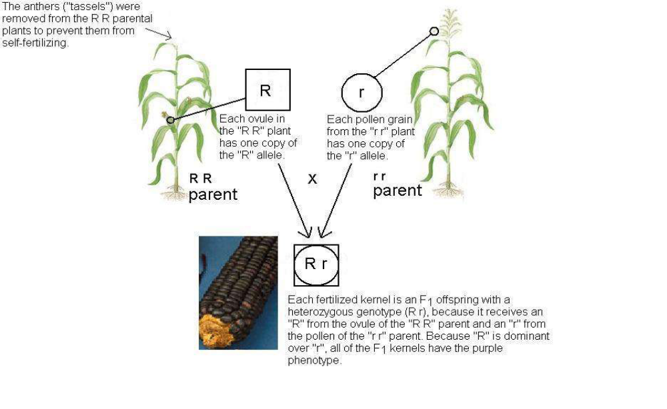
Another way to analyze the outcome of a monohybrid cross is the Punnett’s square. The Punnett’s square method uses a simple grid to match all of the possible combinations of gametes in a cross. The gamete genotypes of one parent are listed along the top of the grid, and the gamete genotypes of the other parent are listed along the side of the grid. By filling in each square with the alleles from the top with the alleles from the side, the different possible combinations of genotypes in the offspring are found in the grid. The following diagram shows a Punnett’s square analysis for the monohybrid cross that was just covered.

Parental (P) generation genotype: R R X r r
Parental (P) generation phenotype : Purple Yellow

Punnett’s square analysis for the parental cross:

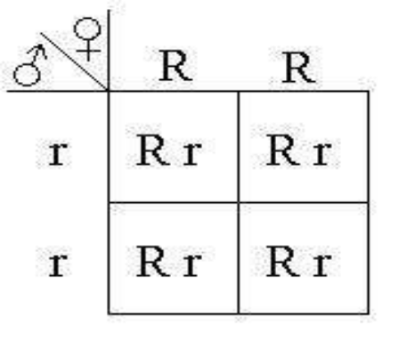
9) If we used the above offspring (F₁) in a new cross, what would be the genotypes and phenotypes of the offspring of the F₂ generation?

10) What is the genotypic ratio of the F₂ generation?

11) What is the phenotypic ratio of the F₂ generation?

12) What would be the genotypic and phenotypic ratios of offspring from a cross between a homozygous recessive parent (r r) and a heterozygous parent (R r)?

13) The ear of corn in front of you (#1) is from the F₂ generation of a controlled cross. Using what you now know about Punnett’s squares, monohybrid crosses, and phenotypic/genotypic ratios, how could you determine the genotype and phenotype of the F₁ parents?

14) What is the phenotype and genotype of the F₁ parents using your method from the above question?
15) What is the phenotype and genotype of the F₁ parents of corn #2?
B. Mendel’s Law of Independent Assortment: When the alleles of two different genes separate during meiosis, they do so independently of one another unless the genes are located on the same chromosome (linked). This is the principle of independent assortment. Mendel discovered independent assortment by performing dihybrid crosses in the pea plant. We will examine dihybrid crosses in maize. Consider the genes for kernel color and kernel composition in maize.
Seed color gene Seed composition gene
R allele, dominant, for purple kernels T allele, dominant for smooth (starchy) kernels
r allele, for yellow kernels t allele, for wrinkled (sweet) kernels

In the P generation, a homozygous plant with purple, smooth kernels was crossed with a plant having yellow wrinkled kernels. The F₁ plants were allowed to fertilize themselves. According to the principle of independent assortment, the color gene and the seed shape gene should not affect one another; that is, they should behave independently.

It is also possible to analyze the dihybrid cross with a Punnett’s square. For a dihybrid cross, we’ll need a 4 x 4 grid because there are four genotypes in the F₁ gametes. Here is the Punnett’s square analysis of the F₁ cross from the above example.

F1 cross= R r T t x R r T t

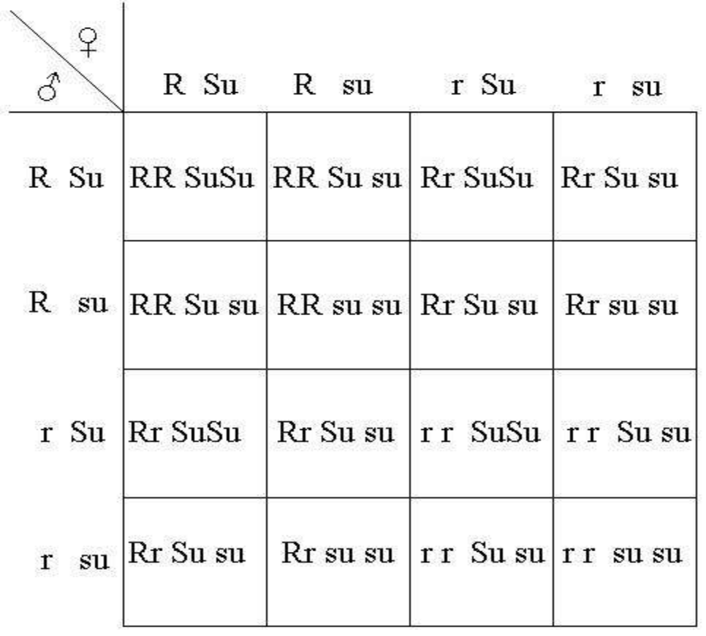
R T R t r T r t

R T

R t

r T

r t
RR Tt

RR TT
Rr TT
Rr tt
RR Tt
Rr Tt
Rr Tt
Rr tt
Rr Tt
Rr TT
Rr Tt
Rr tt
rr TT
rr Tt
rr Tt
rr tt

16) Using what you have learned about Mendel’s law of random segregation and independent assortment, why are all possible combinations of genes used in the dihybrid Punnett’s square? In other words, along the top and side of the above Punnett’s square, every possible combination of genes from each of the parents (F₁) is represented. Why is this necessary? What does it account for?

17) What are the phenotypic and genotypic ratios of the F₂ offspring from the above crosses?

18) Construct a dihybrid Punnett’s square for F₁ parents with genotypes different (your choice) from the above example. What are the phenotypic ratios of the F₂ offspring?

19) In front of you there is offspring (#3) from the F₁ parents of a dihybrid cross. Using a chi-square test, and what you have learned about Mendel’s laws, determine the genotype and phenotypes of the F₁ parents. To answer this question properly, you will need to construct a chi-square table and determine your expected and observed values for each phenotype. In addition you need to correctly identify your null and alternative hypotheses when conducting the chi-square test.

